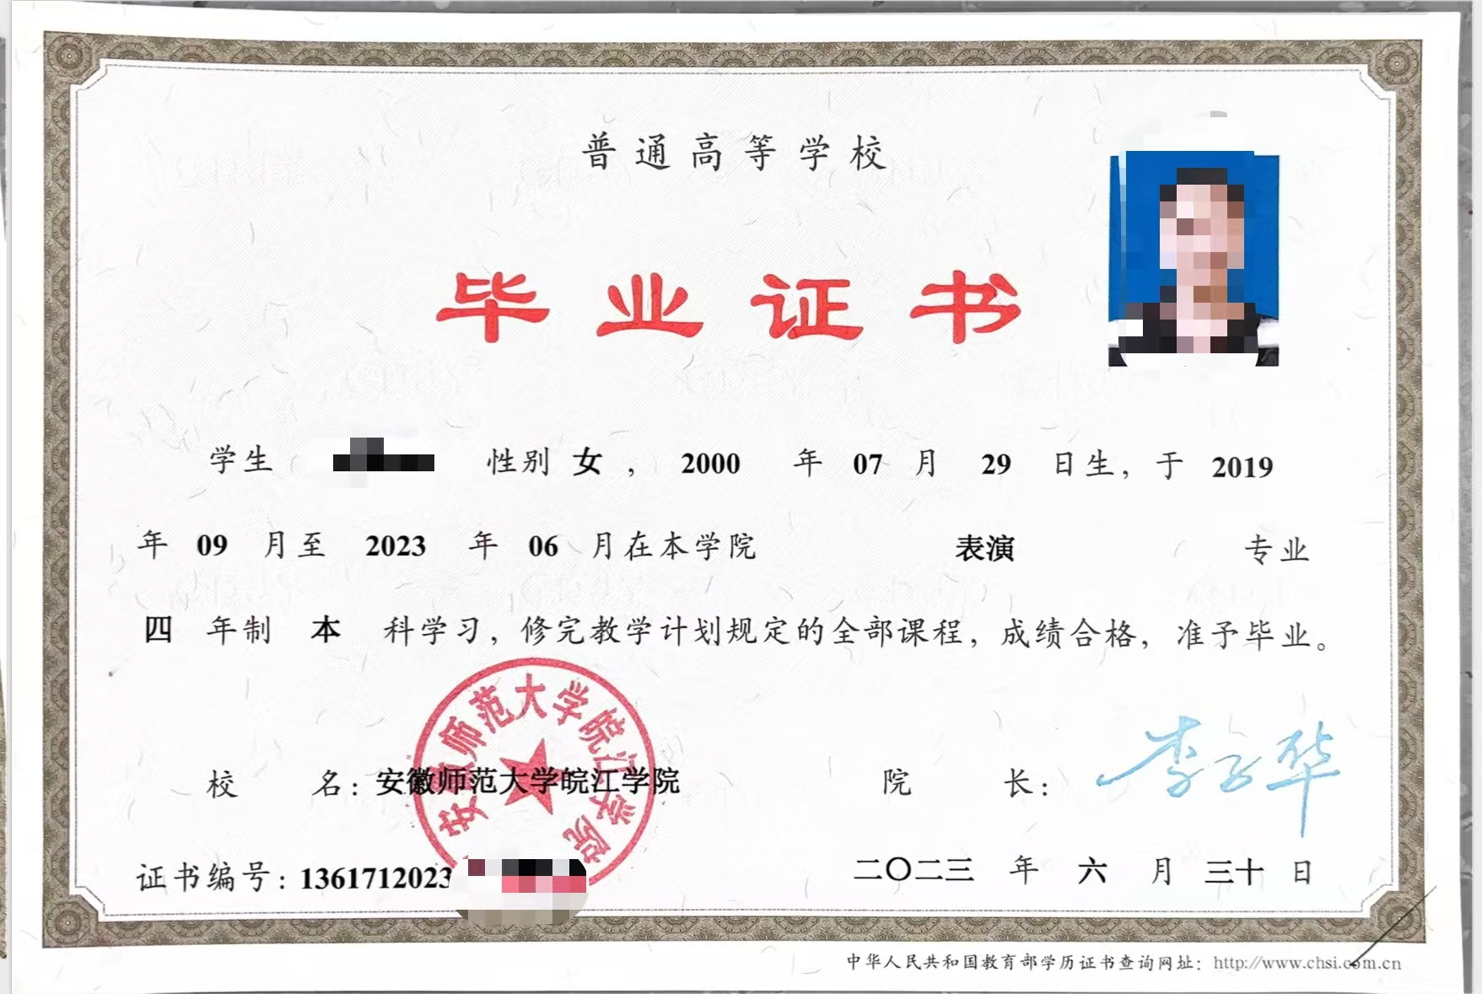

DIPLOMA

Let it be known that Miss A Bc, born on July 29, 2000, having specialized in English in Department of Foreign Language of Wanjiang College of Anhui Normal University from September, 2009 to July, 2013, has fulfilled all the requirements and is up to the standard of graduation, so is granted graduation.
Li Zihua
President of Wanjiang College of Anhui Normal University
Certificate Serial No: 136171201305000000
Date of Issue: July 1st, 2013

