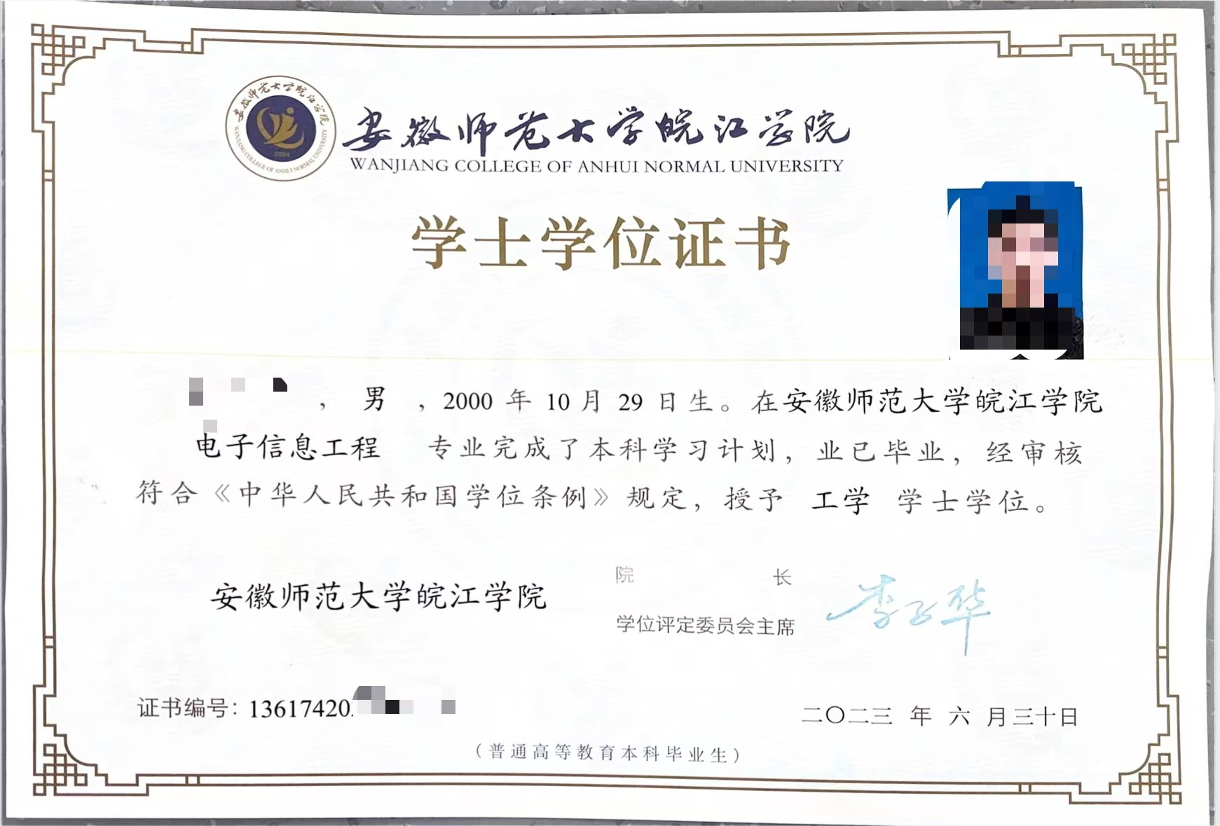

CERTIFICATE OF THE BACHELOR’S DEGREE

This is hereby to certify that Miss A Bc, born on February 06, 1994, having specialized in English in Department of Foreign Language of Wanjiang College of Anhui Normal University from September, 2012 to July, 2016, has qualified for graduation. In accordance with THE DEGREE CONFERRING REGULATIONS OF THE PEOPLE’S REPUBLIC OF CHINA, she is hereby conferred the Bachelor’s Degree of Arts.
Li Zihua
President of Wanjiang College of Anhui Normal University
Certificate Serial No: 1361742016000000
Date of Issue: July 1st, 2016

